Module 7
Sports
- Match two parts of the sentences.
- Football is  - Surfing is  - Skiing is  - Water-racing is  - Boxing is | A)a water sport you do in the sea;  B)a contact sport where you touch another person;  C)an extreme sport that is fast and dangerous;  D)a winter sport that you need snow for;  E)a team sport you play with ten others.

- ___, 2) ___, 3) ___, 4) ___, 5) ___.

- Match two parts of the sentences.
- tennis court  - athletics track  - ski slope  - be fit  - captain  - coach  - referee  - warm up  - train  - spectators | 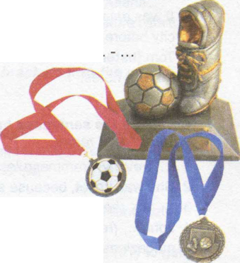  - the person who is a leader of a team  - the place where you play tennis  - if you do a lot of exercise, you will...  - the place where athletes run  - the person who is in charge of a team  - what players do before they start playing  - the people who watch a sport  - the person who controls e.g. a football match  - the place where you ski  - what professional sports people have to do every day
- ___, 2) ___, 3) ___, 4) ___, 5) ___, 6) ___, 7) ___, 8) ___, 9) ___, 10) ___.

- Complete the text with the words: skiing, leader, the Olympics, team games, keep in shape, sports.
My brother loves 1) ______________________. When he was in high school he used to play a lot of 2) _______________________________. He was always the team 3) ________________________. He still plays soccer sometimes on the weekend, and in winter he goes 4) _____________________ or snowboarding. Recently he has started going to the gym three times a week in order to 5)__________________. He also likes watching sport on the television – the World Series, 6) _______________, or even Golf Open Championships – he will watch it.
- ___, 2) ___, 3) ___, 4) ___, 5) ___, 6) ___.

